# Michael Chillemi

# 07/20/2023

# CS 590 - Algorithms

# M9.B2: Module 9 Divide-and-Conquer Creativity Exercises

Problem 11.6.9

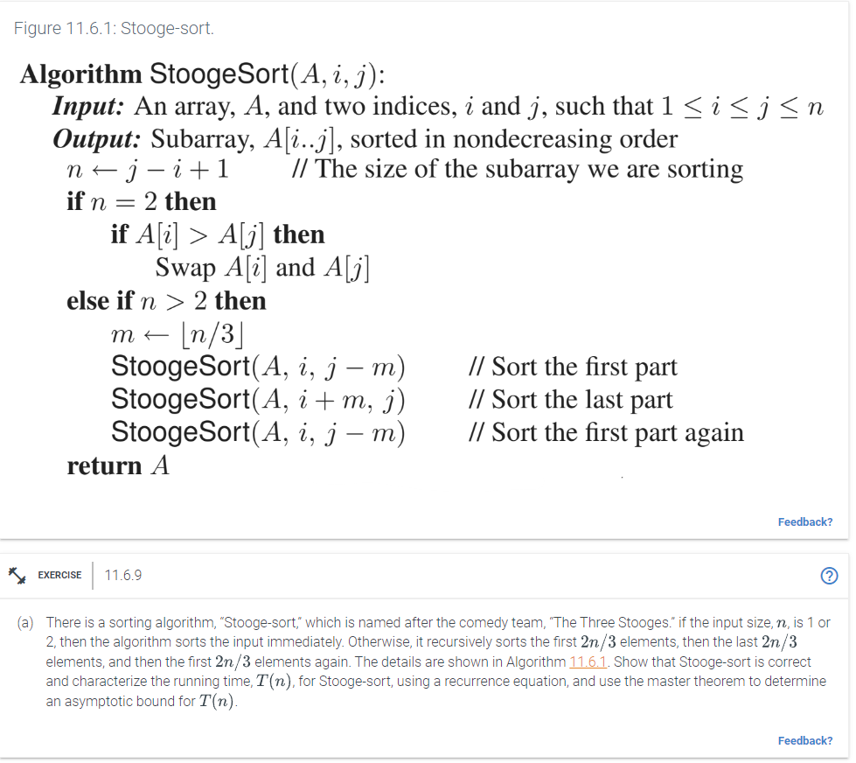

Answer:

Give the recurrence equation's formula for T(n), the Stooge-sort's running time.First the initial 2/3 of the array is sorted iteratively. Second it sorts the final 2/3 of the array. Third It then sorts the first 2/3 of the component to verify. Therefore, when choosing elements, the ceiling of (2/3)*N is always used. The run-time complexity T(n) is therefore 3T(3N/2) +?(1). $O(n^{(\frac{log3}{log1.5})}) = O(n^{2.709})$ for the aforementioned recurrence.

Since the last sentence may be a little hard to read I will rewrite it without using google equation O(n^(log 3 / log 1.5)) = O(n^2.709).